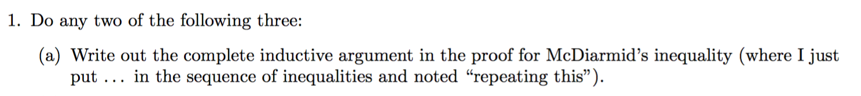

|  |
| --- |
|  |



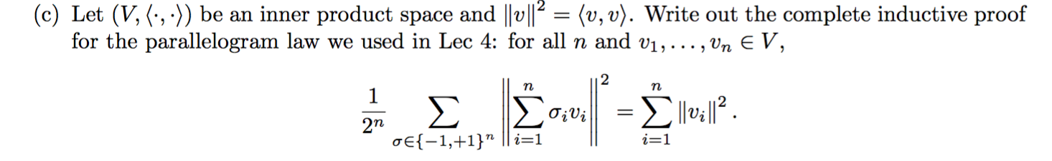

|  |
| --- |
| Acknowledge to Saeedeh(ss3767): |

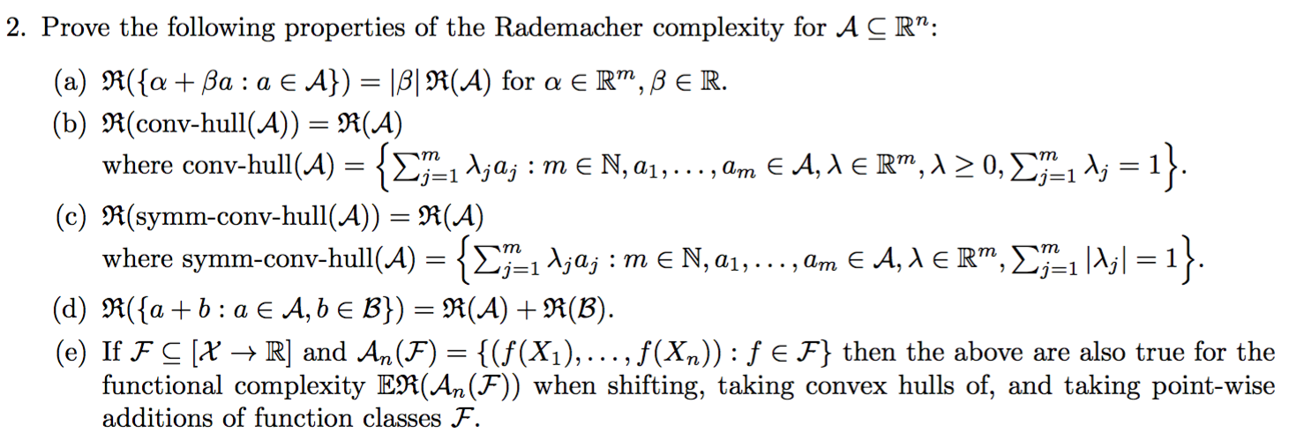

|  |
| --- |
| a)  is |\beta| due to sup over A? |
| b) |
| c)    changing the sign of \lambda should not change the result? |
| d) |
| e)  from X->R1 into Rn ?  point-wise perdiction |



|  |
| --- |
| The standard procedure should be first showing VCdim >=A , then showing VCdim<A+1 |

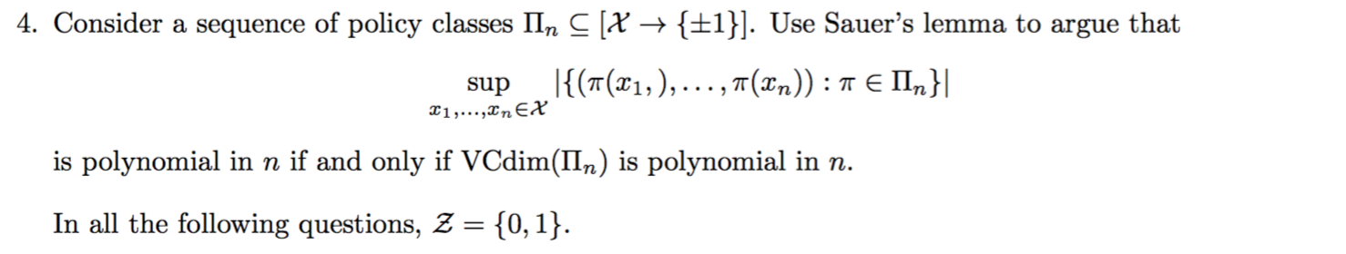

|  |
| --- |
| ? |

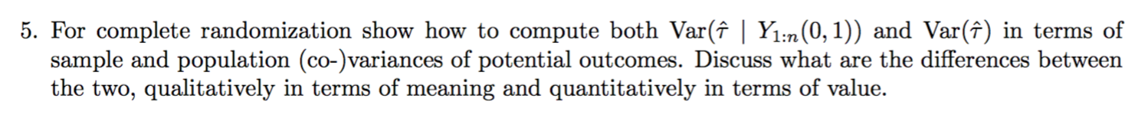

|  |
| --- |
| how to calculate sample outcome treatment effect variance?  Maybe we use model-based statistics like assume effect follows a normal distribution? |

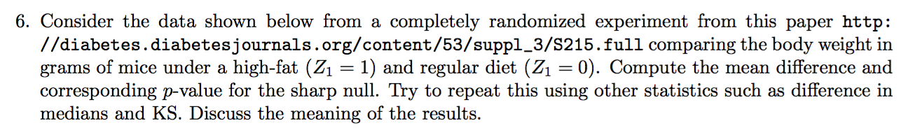

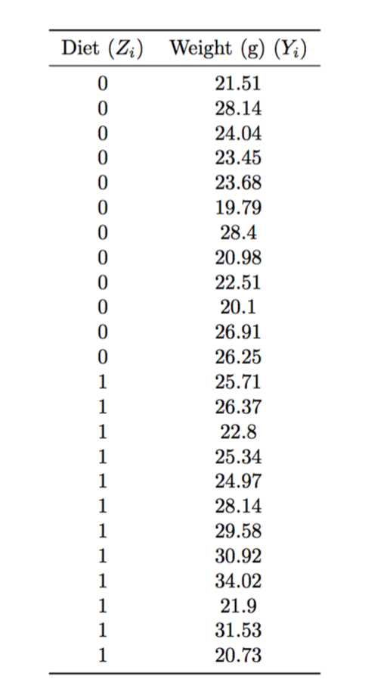

|  |
| --- |
| https://github.com/JessieJingxuGao/Causality-and-Learning-for-Intelligent-Decision-Making/blob/master/hw1-6-PermutationTest.ipynb |

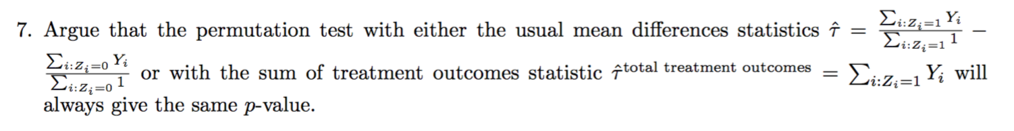

|  |
| --- |
| Acknowledge to Saeedeh(ss3767): |

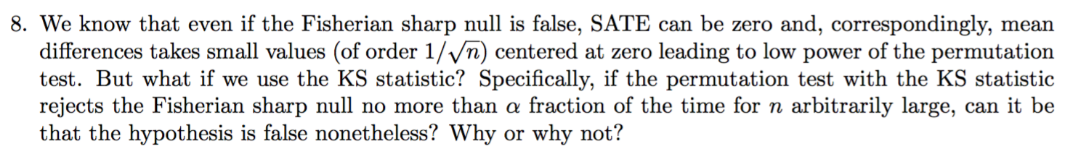

|  |
| --- |
| Acknowledge to [Imbens & Rubin ’15](https://www.cambridge.org/core/books/causal-inference-for-statistics-social-and-biomedical-sciences/71126BE90C58F1A431FE9B2DD07938AB) chapter 5.5.6  If the true distribution for the potential outcomes given treatment is normal with mean zero and unit variance, and the true distribution for the potential outcome given no treatment is normal with the same mean, zero, but a different variance, say, two, focusing solely on the average difference will not generate extreme p-values very often, even in large samples, despite the null hypothesis not holding. Formally, the test based on the difference in averages will have little power against an alternative hypothesis with different variances.  We may, therefore, be interested in test statistics that would be able to detect, given sufficiently large samples, any differences in distributions between treated and control units. An example of such a test statistic is the Kolmogorov-Smirnov statistic.    ? This is just the case that the data couldn’t support. |

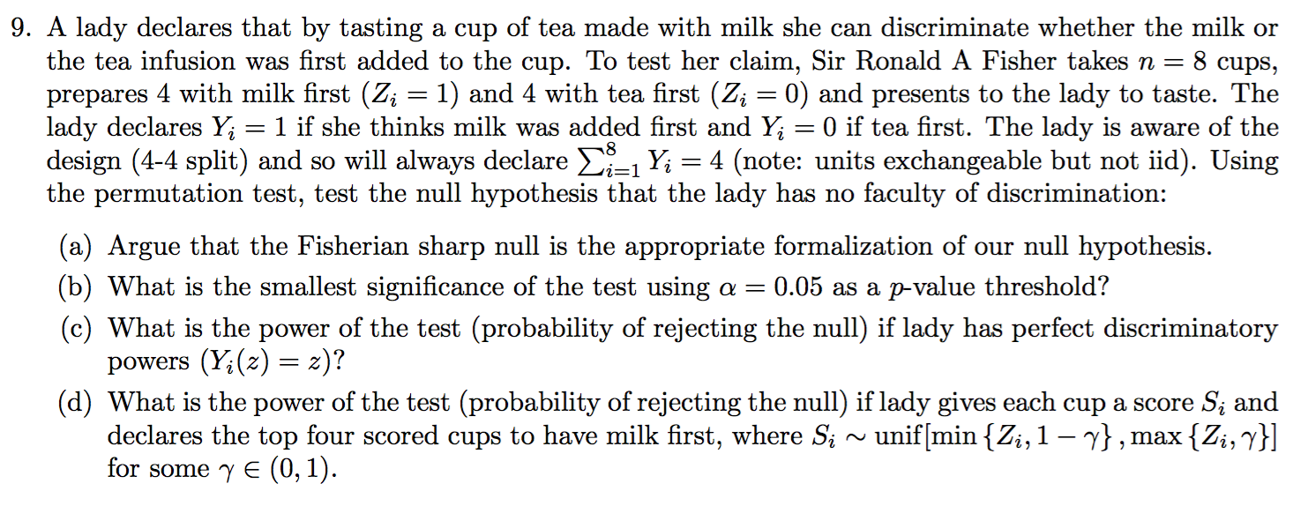

|  |
| --- |
| <https://github.com/JessieJingxuGao/Causality-and-Learning-for-Intelligent-Decision-Making/blob/master/hw1-9-LadyTea.ipynb>  ?question d: question d may need numerical proof rather than simulation. |

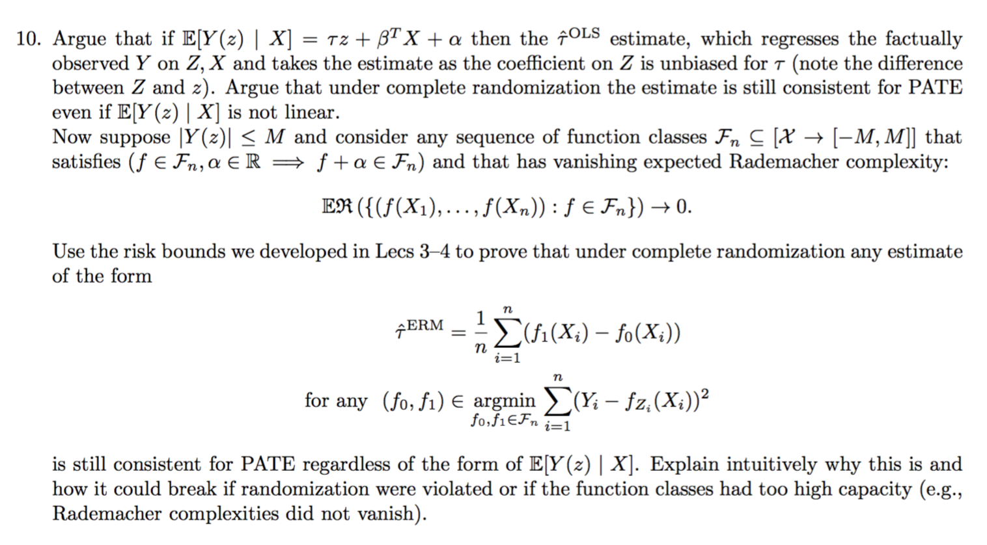

|  |
| --- |
| [Imbens & Rubin ’15](https://www.cambridge.org/core/books/causal-inference-for-statistics-social-and-biomedical-sciences/71126BE90C58F1A431FE9B2DD07938AB) chapter 7.5 talks about why OLS derives consistent estimator for PATE under CR.  (it seems that in lecture 20, the OLS adjustment as a GOM method is similar with this) |
| ? How to prove rademacher complexity doesn’t vanish with regard to randomization. |